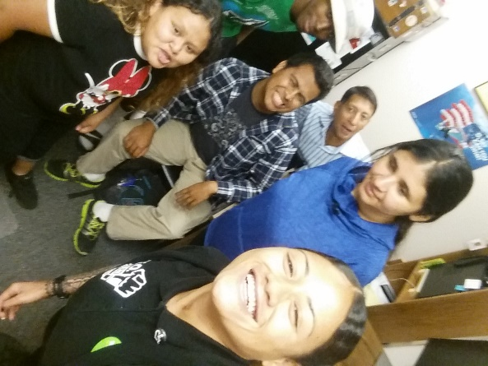 ­­­­



Take charge of your own future!

Make it whatever you want it to be!

***Dream Big, Live Large.***

Every Wednesday & Friday,

1:00-3:00 p.m.

Gino Elliot, Peer Support/

Independent Living Skills Coordinator

**Disabled Resources Center, Inc**.

2750 E. Spring St., Suite 100

Long Beach, CA. 90806

562.427.1000 ext. 123

[gelliot@drcinc.org](mailto:gelliot@drcinc.org) 

**You are not alone!**

The mission of **DRC** is:

***“To empower people with disabilities to live independently in the community, to make decisions about their lives and to advocate on their own behalf.”***

Disabled Resources Center, Inc.

2750 E Spring St. Suite 100

Long Beach, Ca. 90806

Phone: 562.427.1000 TTY: 562.427.1366

www.drcinc.org

E-mail: [info@drcinc.org](mailto:info@drcinc.org)

DRC is a scent free facility.

Contact DRC if reasonable accommodations are needed.

Provided by

**Disabled Resources Center, Inc.**

**This group will empower young adults with disabilities to have fun, make new friends, find valuable entertainment, learn and claim your rights, develop more independent living skills, increase your self-confidence, and work together to help each other be more successful**.

# TRANSITIONAL YOUNG ADULTS GROUP



*Aging out of Foster Care?*

*Starting College?*

*Beginning Employment?*

*Facing other challenges?*